Daily File Namer
Code:
from airflow import DAG # type: ignore
from airflow.providers.standard.operators.python import PythonOperator # type: ignore
# from airflow.operators.bash import BashOperator
from airflow.providers.standard.operators.bash import BashOperator
from datetime import datetime

def name_the_file_func(**context):
ds = context['ds']
ds_nodash = context['ds_nodash']

print(f"Naming file for date: {ds}")

file_path = f"/reports/{ds_nodash}_daily_report.csv"
print(file_path)

return file_path

def explain_execution_date_func(**context):
ds = context['ds']
yesterday_ds = context['macros'].ds_add(ds, -1)

print(f"1. This run's ds is: {ds}")
print("2. ds is one day behind because Airflow only processes data AFTER the day is finished.")
print(f"3. So this pipeline is processing data from: {yesterday_ds}")

with DAG(
dag_id="daily_file_namer",
schedule="0 8 * * *",
start_date=datetime(2024, 1, 1), # every day at 8 AM
catchup=False
) as dag:

show_template_vars = BashOperator(
task_id="show_template_vars",
bash_command="""
echo "Run date: {{ ds }}"
echo "Date no dashes: {{ ds_nodash }}"
echo "Yesterday: {{ macros.ds_add(ds, -1) }}"
echo "Tomorrow: {{ macros.ds_add(ds, 1) }}"
echo "DAG: {{ dag.dag_id }}"
echo "Task: {{ task.task_id }}"
echo "Run ID: {{ run_id }}"
"""
)

name_the_file = PythonOperator(
task_id="name_the_file",
python_callable=name_the_file_func
)

explain_execution_date = PythonOperator(
task_id="explain_execution_date",
python_callable=explain_execution_date_func
)

show_template_vars >> name_the_file >> explain_execution_date # type: ignore

- Graph View — all 3 tasks GREEN in order: show_template_vars → name_the_file →explain_execution_date
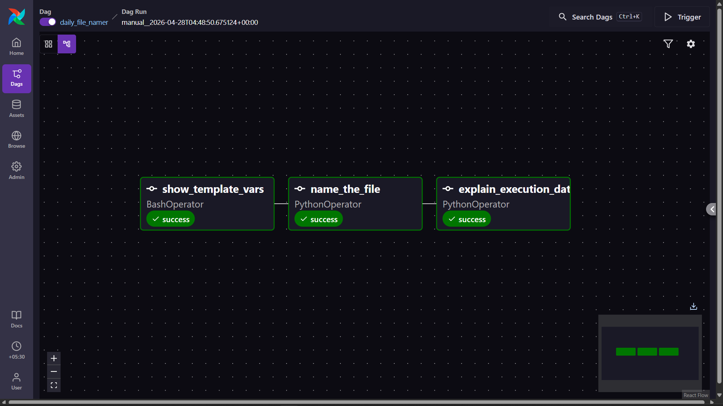

- Task Log of show_template_vars — BashOperator output showing all 7 variables with real resolved values
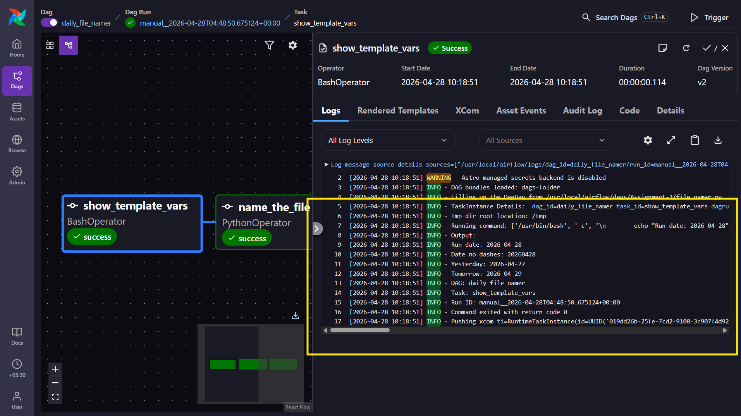
- Task Log of explain_execution_date — your 3 printed lines using the actual ds and yesterday_ds values
